MHS Home & School Meeting Minutes
November 7th, 2024 9:15am Rm C149

Attendees: Dr. Euker, William Peck, Susan Demedio, Sophia Pham, Deanna Roeger, and Michelle Jackson-Greenwalt
MHS Reports:
Principal-Dr. Euker explained that only for the first marking period, students can only get as low as a 50% (even if they are below it). Grades after that that fall below 50% will be reported as they are and not at 50%. Parents are encouraged to monitor students grades via Powerschool. Teachers will now also report to parents once a student’s grade is under 60%. The cell phone and hall passes have been going well and she’s encouraging all to keep enforcing it as the year goes on as it is important for everyone’s safety. Being consistent during change helps transition to long lasting effects when all are united together in the process. Dr. Euker is trying to be more visible for the student body by doing announcements a few days a week and showing up to different after school activities and clubs. She also does carline daily and that has been going well. The last in-service the staff focused on how to engage students more so that they are actively participating as opposed to passively to increase student engagement in the classrooms.
Teachers-Andrea Borgmann sent along the following that Susan Demedio shared:
AREA | NEWS
NURSES OFFICE   | During our Student Blood Drive last week- 73 units of blood were collected!  Eight of our students were Power Red donors! (donating a concentrated 2 units of red blood cells).
SCIENCE   | Dr. Cocozza’s AP Environmental Science class went to Fairmount Park Water Works. It was an amazing hands-on trip. Here are a few photos in an album from the trip.  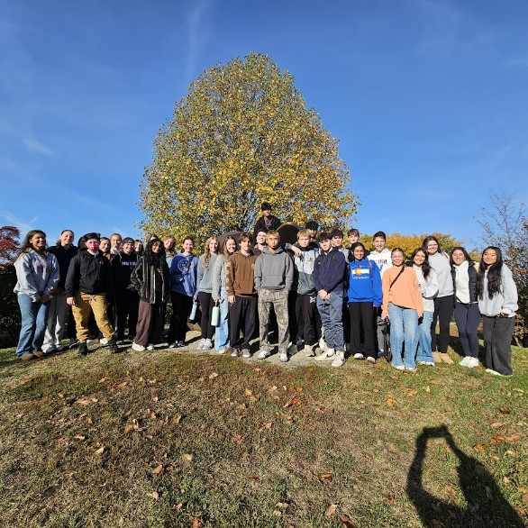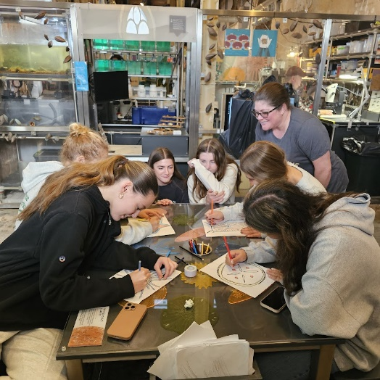
Theater   | Clothes4Cash Fundraiser!  We are accepting gently used clothing, shoes, belts, handbags, etc. Items must be in at least a 13 gallon or larger trash bag. Items can be dropped off outside at the front Auditorium Lobby entrance on Saturday, November 9th between 9 am and 11 am preferably. Please do not drop off after 4:00 pm  PLEASE DO NOT DONATE TORN, RIPPED, SOILED OR STAINED ITEMS. THEY ALSO WILL NOT ACCEPT BEDDING, TOYS, STUFFED ANIMALS, ETC.
Technology  And  Engineering   | Methacton Technology and Engineering education:  Mr. Kralik’s Introduction to Engineering Design classes have been learning AutoCAD Computer Aided Drawing software. AutoCAD is an industry standard CAD program that provides a foundation of CAD knowledge for the students. Up next is using AutoCAD to design laser cut Tea light holders.  The 3D Modeling and Printing classes have been practicing their 3D design skills while creating model castles which are being 3D printed. The students are very excited to hold the printed models with all of their awesome details.
SUMMER  TRAVEL  SENIOR  PARENTS | Mr. Alzamora would like to announce that there is a France 2026 trip informational meeting on Tuesday Nov 19th at 7 pm in the Cafe.    Please be reminded to order Yearbooks from Jostens.com.  Senior parents can also order a “Baby Ad” on the site for their Senior.  Step 1: Visit www.Jostens.com & click “shop your school” Step 2: Enter “Methacton” and find the High School Step 3: Click “Yearbook Recognition Ad”
CHEER TEAM   | 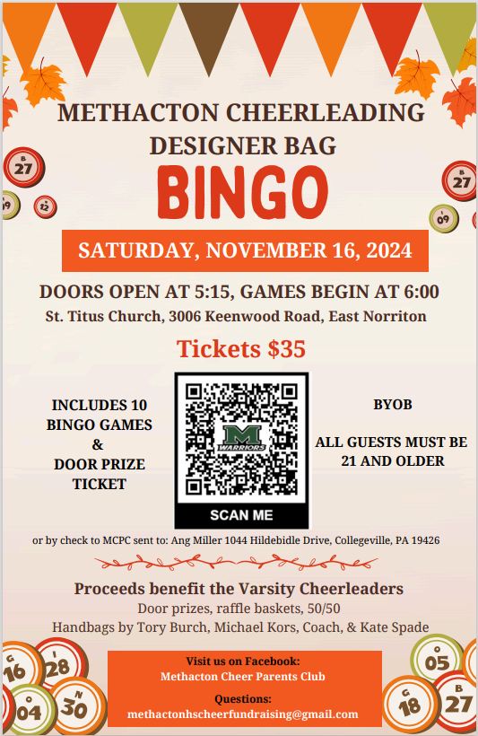
THEATER | Theatre Company is presenting “A Christmas Carol”.  Performances are November 14/15/16, all at 7pm.  Tickets on sale through Hometown Ticketing.  $7 students, $15 Adults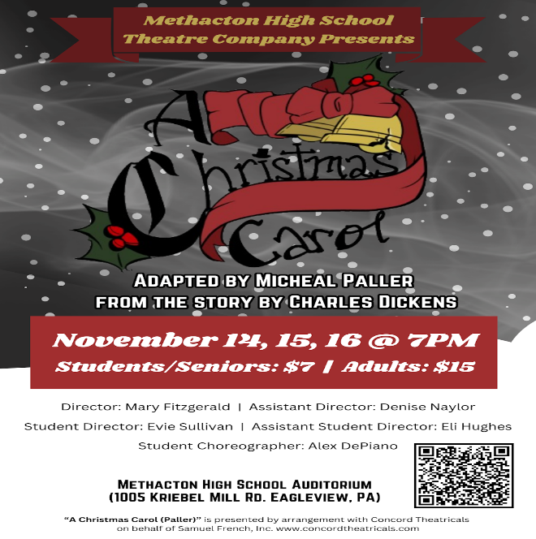
 | MHS TEACHER COSTUME CONTEST
 | 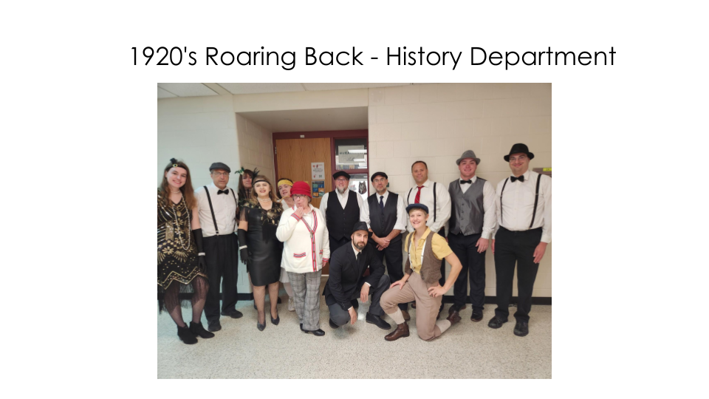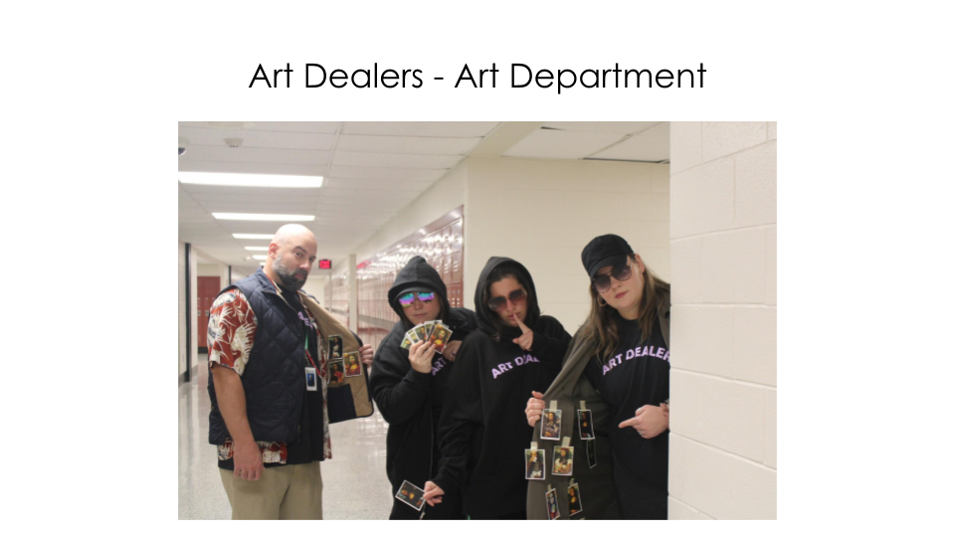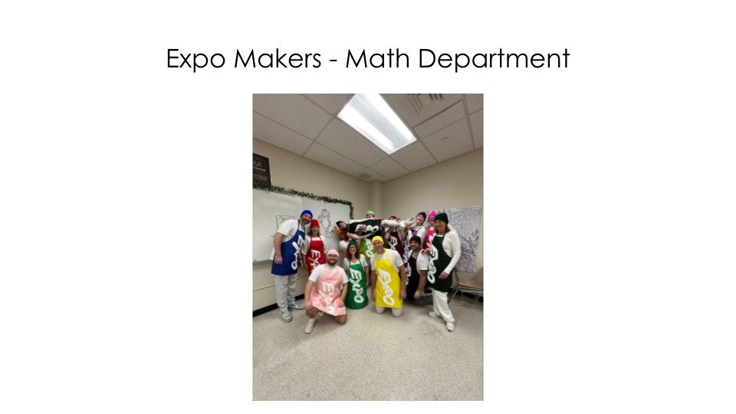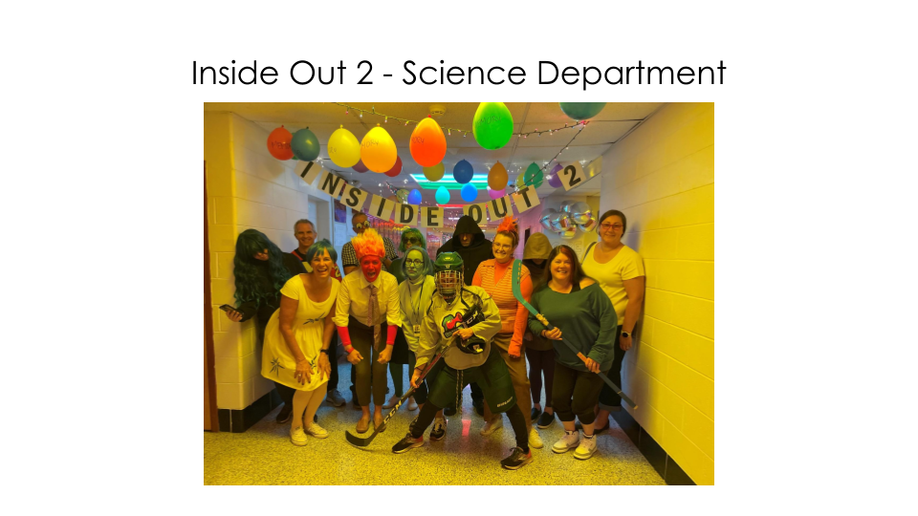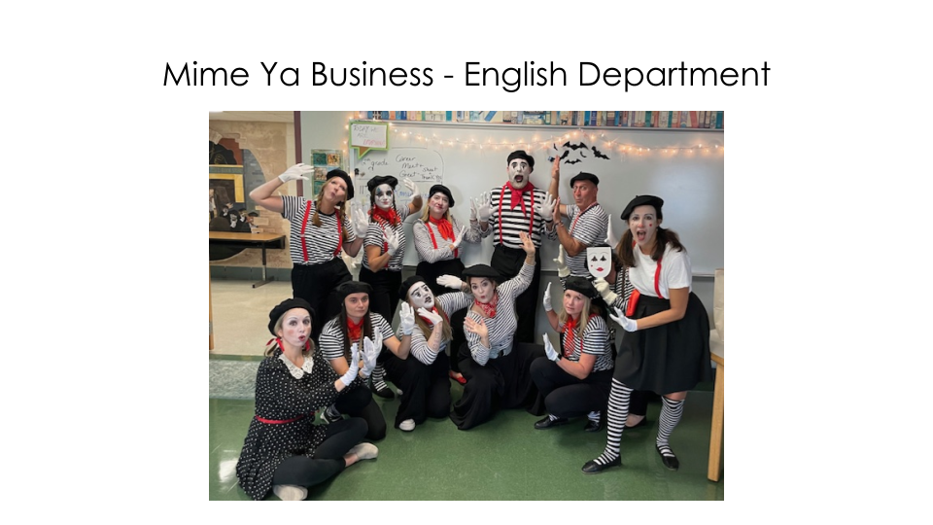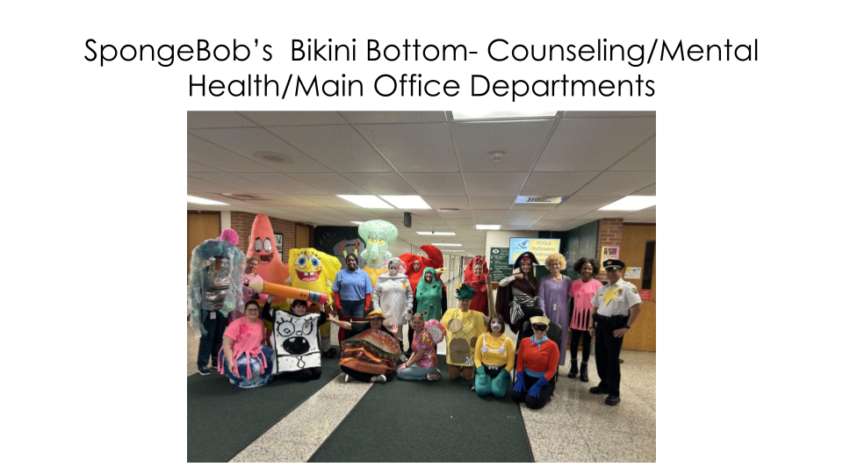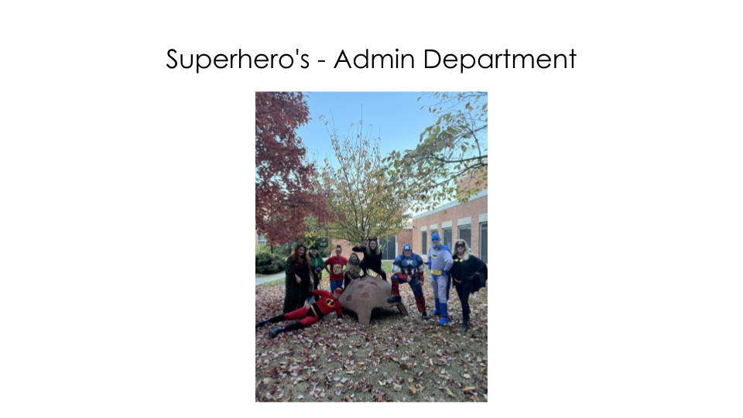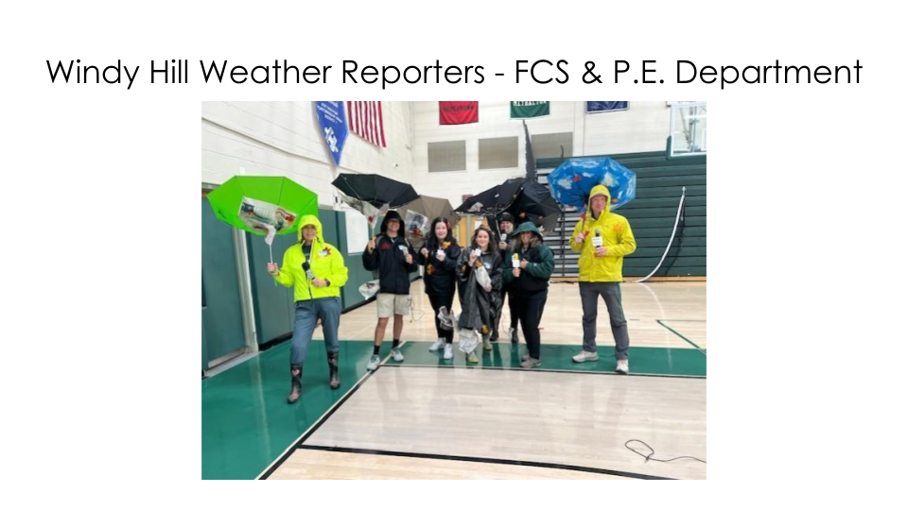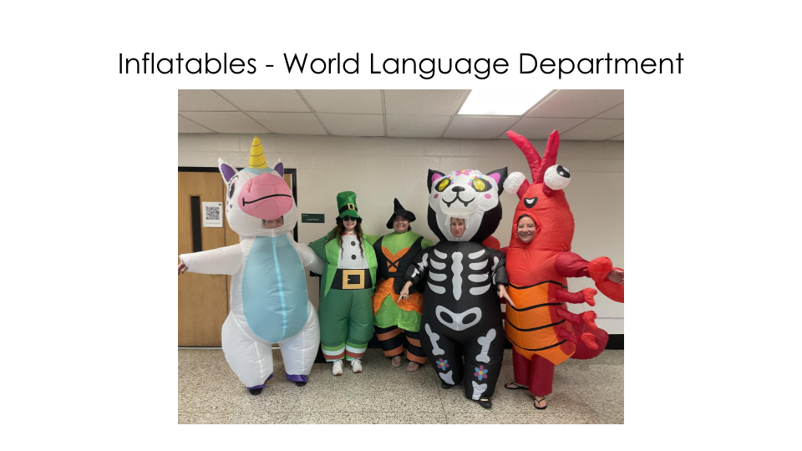
 | END

Counseling- William Peck shared the Following:
PSAT’s
- October 9 10th and 11th grade 774 students took the PSAT
- Scores were released to students beginning October 24th
- Counselors will be presenting to the 10th and 11th grade students later this month in the science classes to review their scores and how to improve and prepare for the SAT’s
FAFSA Completion Night
- Thursday 12/12/24 from 6:00 to 8:00 PM in the High School Library
- Cindy Whitley form MCCC Fincial Aid Office will be assisting families with FAFSA questions
- Information and the link to register is on the High school calendar
- Capped at 20 families
Financial Aid Night
- Tuesday 1/14/2025 from 6:00 to 7:30 PM in the High School LGI
- Michael Burke from PHEAA
- Katrina Kelly from West Chester University Office of Financial Aid
Parochial Day
- January 29 from 8:00 to 10:00 AM
- Morning program for prospective new students coming from the parochial schools. Tour and presentation
Seniors
- 60% or 262 students have already applied to college
- 1st Quarter Grades – some colleges may request the grades for consideration
  - Need to complete a form available from the counseling office
  - Will be available to send out week of 11/18
- Acceptances – Please make a copy and drop off in the counseling office with Mrs. Gracie as well as any scholarship offers
New items:
- School Links being piloted by the counselors as a potential replacement for Naviance
- Character Strong – a K-12 MTSS program to improve climate and foster a sense of respect and support for students
- Social media Interns
  - Two MHS students will be helping communicate to the student and community populations items occurring at the High School as well as the counseling office
H&S Reports:
President- Susan Demedio shared lack of signups for Souper Luncheon and thoughts of going forward thinking we may need to change what is offered due to lack of donations. Deb will put on the top of her announcements that are emailed out to families.
Vice President-Katie Shireman’s info was emailed and Susan read it. Katie shared that sign ups continue to come in for souper luncheon.
Treasurer-Sophia Pham shared that we had $908 in expenses in October due to approved mini grants, career day snacks, and winning warriors’ items. We currently have $10,663.53 in the bank and recieved$1451.53 for no frills and some souper luncheon monetary donations. A bunch of no-frills had been sent back in with the info sent to the nurses and they were in the office and we did not know.
Recording Secretary- Deanna had nothing to Report
Corresponding Secretary- Chrissy had nothing to report.

District Reports
SEA- Michelle shared the following:
1. Thank you to everyone who attended our Fall Fest last month! It was delightful connecting with families, new and old, while snuggling with farm animals. We’re looking forward to holding it again next Fall!
2. We hope everyone was able to attend our Transition presentation by Kris Koberlein. If you registered, the link to the recording should be emailed within the next week.
3. Our next Home & School meeting will be held November 20th at the MHS Library, 7:00pm. Dr. Dani Fowlston will be giving us an update on Supports and Services and staffing at Arcola and Skyview.
4. Our next presentation will be by Dr. Steve Stunder from Chestnut Hill College on College Access for Neurodiverse Students, November 21 at 7:00pm. Stay tuned for the flyer for details and registration in the very near future.
5. Watch for the Unified Bocce team’s competition schedule coming very soon! Their season begins 11/18. Take some time to come cheer them on at their home games!
6. Join the SEA Home & School to tour Variety’s Holiday Lane, December 5th through 7th! Stay tuned for a date and time for our meetup.
7. Save the date for our annual Kendra Scott fundraiser to be held the weekend of December 13-15! Stay tuned for a flyer and details!
8. Check out SEAofMCC on Facebook to find out more about the following: a. Empower EdSchool Solutions #NoExcusesNovember daily clarifications on faulty reasoning often used in discussions regarding inclusive practices. b. Coffee Closet with Barista Jake’s “Inclusion Revolution” Holiday Shopping Event on Wednesday, 12/4 from 6-9pm. Vendor info available as well c. TIES Center Universal Design for Learning Modules, to learn more about this framework and how to support educators to design learning experiences that are inclusive for each and every learner d. Right To Education- Montgomery County Local Task Force 23’s Families To The Max 2024 Fall Foundational Courses, virtual trainings, free of charge. e. Local Task Force Listening Sessions hosted by Dr. Carole Clancy, (director of the Department of Special Education for PA Department of Education) and Ms. Sherri Landis (director of The Arc of Pennsylvania). 9. Asalways, please contact SEAMethacton@gmail.com with any questions or concerns.
Post Prom- Katie shared (via email) that the next meeting is Tuesday, November 12 at 7p in the MHS Library. The east wing of the building will be open on Wednesday, November 6 and November 20 as well as Wednesday, December 4 and December 18 from 6 to 8 PM for groups to come in and look at props and backdrops for their theme. Painting will begin after the new year. Please enter East Wing doors
School Board-Susan shared that they voted and approved the next phase of the new high School.
MCC- Meeting is Monday November 11 at 7p via zoom. Katie plans to attend.
Dates to Remember:
November
14th-SOUPER LUNCHEON
14-16th- 7pm FALL PLAY
27-29- NO SCHOOL (Thanksgiving Break)

December
23rd through January 1ts- NO SCHOOL (winter break)

